**Data Structures and Algorithms**

**Lab Report**

**Lab05**



|  |  |
| --- | --- |
| Group Members Name & Reg #: | **Muhammad Haris Irfan**  **(FA18-BCE-090)** |
|  |  |
| Class | Data Structures and Algorithms CSC211 (**BCE-3B**) |
| Instructor’s Name | Dilshad Sabir |

**Pre-Lab Task**

**Task:1**

**Implement the peek function to familiarize yourself with this implementation of stack.**

**Solution:**

The code is shown below,

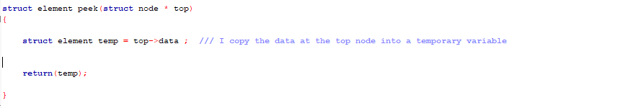

The Result of the following code is attached below:

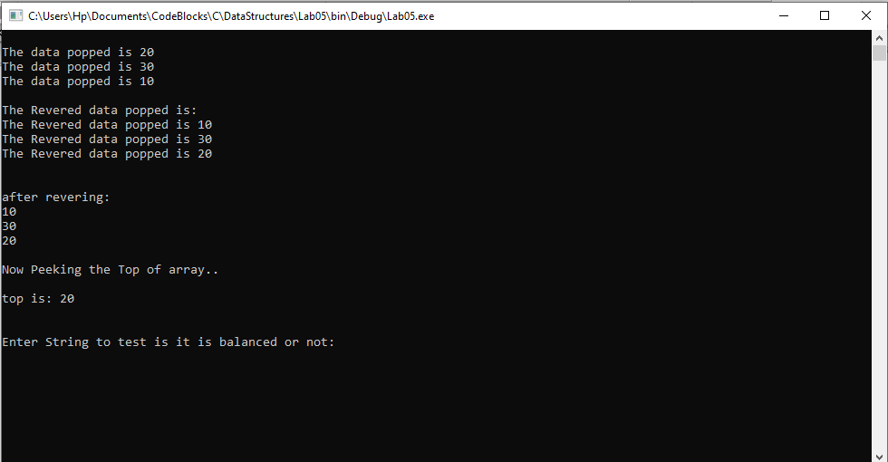

-------------------------------

**In Lab Tasks**

**Task:1**

**Reversing an array of numbers.**

**Solution:**

The code is shown below,

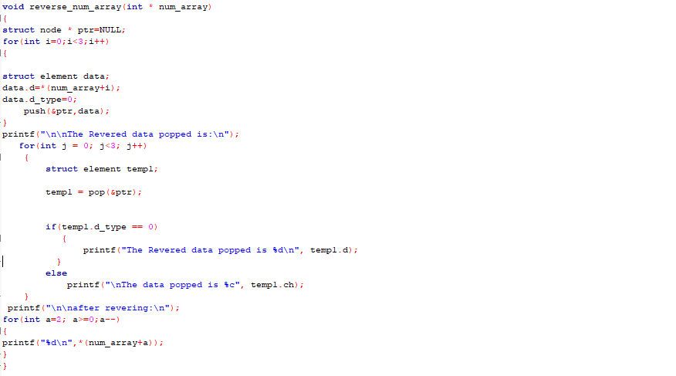

The Result of the following code is attached below:



-------------------------------

**Task:2**

**Testing if a mathematical expression is balanced or not.**

Solution

The code is shown below,

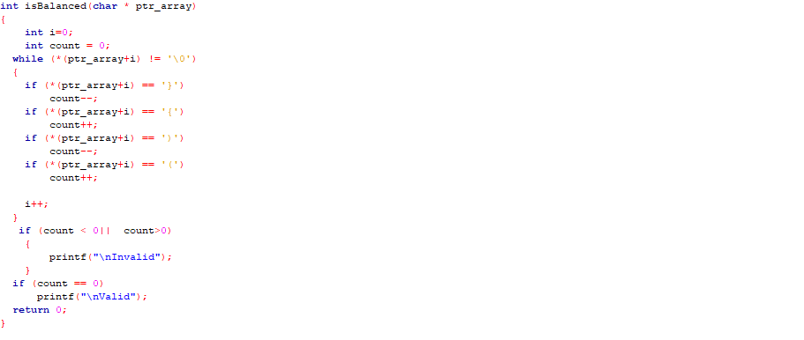

The Result of the following code is attached below:

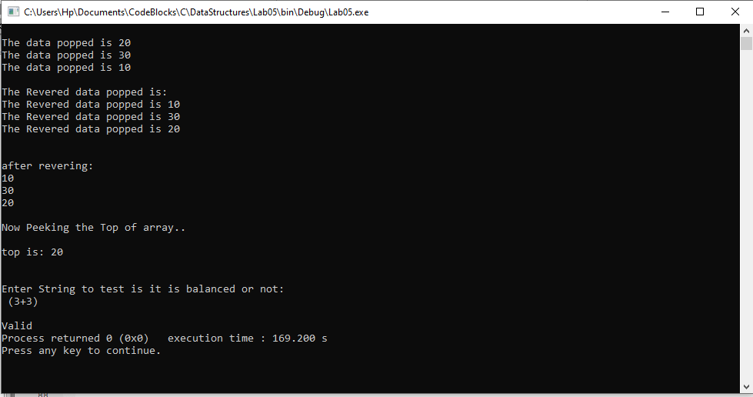

------------------------------

**POST LAB**

**Question no:3**

**Infix to postfix conversion**

Solution

The Result of the following code is attached below:

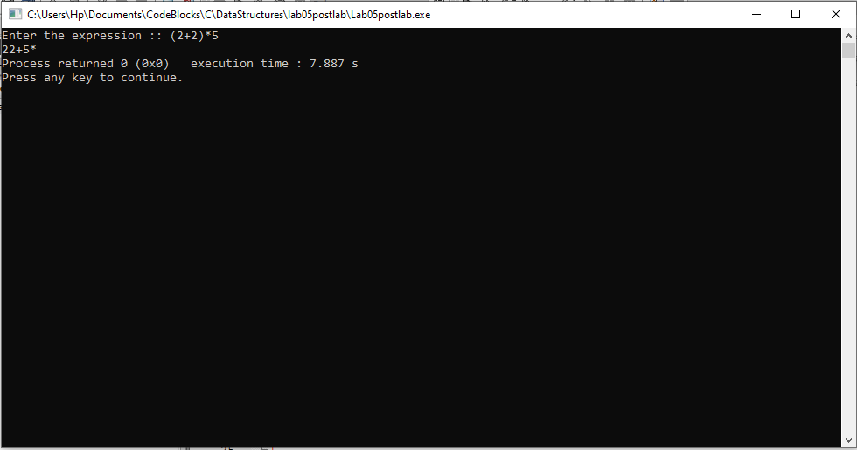

------------------------------

THE END